**Assignment 16 Linux routing table. Default gateway DGW or just Gateway GW.**

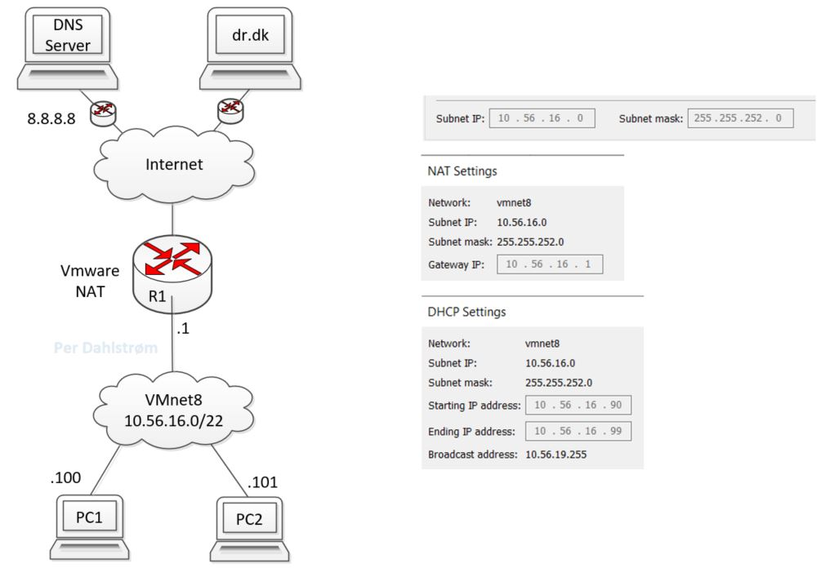

Network diagram used as outset in this assignmenht. The VMWW Virtual Network Editor settings for VMNet8 are shown for reference.

**Introduction**

This assignment is using the VM Ware Workstation VMWW hardware and network virtualisation management tool.

**Learning goals**

After this assignment the student can work with and/or explain:

* The very basics of an IP packets. Source and destination address and payload.
* List the routing table on a Linux box and evaluate if the routing table is correct compared to a network design.
* Identify the Default Gateway in a Routing table and evaluate if the Gateway is correct compared to a network design.
* Manually add, delete and modify routes in a Linux routing table using the ip program.
* Test and troubleshoot a linux routing table mainly by using the ping program as testing tool.¨

**Linux Commands:**

$ ip neigh or $ arp (Listing the ARP table with IP and MAC addresses.)

sudo ip route del default

$ ping

$ sudo wireshark

**Windows commands:**

C:\>route print (route is NOT taken on in this assignment.)

**Tasks:**

**1. Draw the network diagram and configure the PCs**

* Draw the network design or network diagram.
* Configure the PCs network interfaces settings according to the network diagram.

**2. Verify the Linux routing table configuration.**

* List the routing table on PC1 and PC2 and compare to the design.  
  Explain:
  + What is the Default Gateway DGW in the table?
  + What is the route to the directly connected network?
  + Any other route listed in the table.
* Verify that the routing table works:
  + Ping e,g, 8.8.8.8. Explain if it works.

**3. Change the DGW address on PC1 and PC2 to be different from the R1 IP addresss.**

* On both PCs configure the DGWs to a new IP address that is not 10.56.16.1. It has to be the same address i.e. DGW on both PCs. The address has to be between 2 and 254 and should not be between 90 and 99.
* Draw a new network diagram to match this error prone network.
* List the routing tables and compare to the design.  
  Explain:
  + What is the R1 address, in the network diagram?
  + What is the Default Gateway in the table on PC1 and PC2?
  + Is this a problem?
  + Does a wrong gateway prevent PC1 and PC2 from pinging each other?
    - Why/Why not?
    - Verify by pinging between the PC1 and PC2.
  + Does ping to an address on a network on the internet work?
    - Why/Why not?
    - Ping e.g. 8.8.8.8.
    - Show what the output from the ping program says and explain what it means.
      * Output example for PC1:  
        From 10.56.16.100 icmp_seq=1 Destination Host Unreachable
  + Run Wireshark with Display Filter icmp
    - Why does Wireshark not show any ping/icmp ip packets when pinging to the internet , e.g. ping 8.8.8.8?
    - List the PC1s ARP or MAC table. $ ip neigh
    - Why is the Gateway entry ... dev eth0 INCOMPLETE?

**4. Change i.e. correct the R1 IP address to the DGW address set on PC1 dn PC2**

* Change the router R1 IP address in VMWW Virtual Network Editor NAT settings for VMNet8 to the address set as the DGW the PC1 dn PC2 above. In Virtual Network Editor the R1 address is called: Gateway IP:

Change the red marked R1 IP address to match the DGW address set on PC1 and PC2.

* Draw or correct the network design or diagram accordingly by correcting the R1 IP address.
* Explain/show:
  + What is the R1 address, in the network diagram?
  + What is the Default Gateway in the routing tables on PC1 nd PC2?
  + Is this a problem?  
    Does ping to an address on a network on the internet work?
    - Why/Why not? Ping e.g. 8.8.8.8.

**5. Delete the DGW on PC1 and PC2**

* Delete the DGW on PC1 and PC2 by means of the ìp program.
  + $ sudo ip route del default
  + $ sudo ip route del 0.0.0.0 via 10.56.16.10 dev eth0
* Delete the APIPA route
  + $ sudo ip route del 169.254.0.0/16
* Please note that the DGW must also be deleted in the Network Manager interface eth0/ens33 Network Connections. Otherwise this configuration will reinstate the DGW in the routing table upon a restart of the interface.
* Draw or correct the network design or diagram accordingly
* List the routing tables and compare to the design.  
  Explain:
  + What is the Default Gateway in the design?
  + What is the Default Gateway in the table?
  + Is this a problem?  
    Does ping to an address on a network on the internet work?
    - Why/Why not? Ping e.g. 8.8.8.8.
    - Show what the output from the ping program says and explain what it means.
      * Output example for PC1:  
        pi@PC1:~ $ ping 8.8.8.8 -c 1  
        connect: Network is unreachable
  + Does a missing gateway prevent PC1 and PC2 from pinging each other?
    - Verify by pinging between the PCs.

**6. Reestablish manually the DGWs on PC1 and PC2**

* $ sudo ip route add default via 10.56.16.10 dev eth0
* $ sudo ip route add 0.0.0.0 via 10.56.16.10 dev eth0 Is not recognised as the default gateway? Why not?

**7. Misconfigure the routing table on PC1**

Misconfigure the routing table on PC1 by deleteing the route to the 10.56.16.0/22 network and flushing the ARP table:

* $ sudo ip route del 10.56.16.0/22
* $ sudo ip -s -s neigh flush all
* Does ping to an address on a network on the internet work?  
  * Why/Why not? Ping e.g. 8.8.8.8.  
  * Show what the output from the ping program says and explain what it means.
* Does ping to PC2 work?  
  * Why/Why not?  
  * Show what the output from the ping program says and explain what it means.

**8. Ping program outputs**

* From the above "experiments", compile a debugging list that in oneliners explains what misconfiguration(s) will generate the folowing icmp or ping messages:
  + Destination Host Unreachable
  + connect: Network is unreachable
* Go online and investigate how these outputs from the ping program occur:
  + No route to host {Will be a reply from a router firewall.}
  + Request Timed Out

**Hand in**

Hand in a lab report with:

1. Document the above tasks with the network designs used.